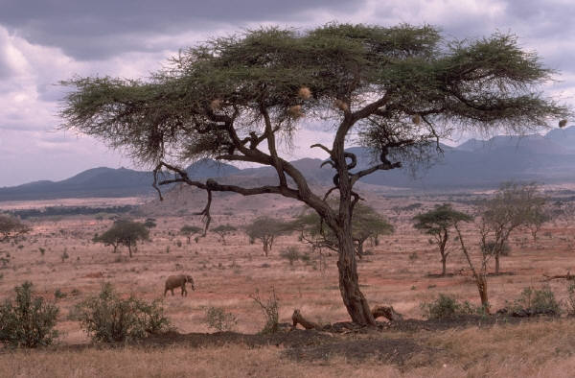

### Kenya Travel Information

**Area**: 580,367 square kilometers

**Population**: 34,707,000

**Languages**: Swahili and English

**Religion**: 45% Protestant, 34% Roman Catholic, 10% Muslim, 10% Other

**Local Time**: GMT + 3 hours

**Electric Supply:** 240v VAC at 50 Hz.

**Local Currency**: Kenyan Shilling

**Recommended Currency**: You will need U.S. dollars cash for spending money. Please be aware that notes issued pre-2002, or ones without the “big face”, are not normally accepted in East Africa.

**Foreign Exchange**: Banks or Foreign Exchange offices are located in cities.

**ATMs and Credit Cards**: Cash can be drawn on ATMs in Nairobi and Mombasa. Credit cards are accepted in larger hotels, and in some shops and restaurants.

**Recommended Reading**: Felice Benuzzi: *No Picnic on Mount Kenya*; Isak Dinesen: *Out of Africa*; Charles Miller: *The* *Lunatic Express*; Ernest Hemingway: *Green Hills of Africa*.

*Source:* Wikipedia.org